DAA LAB 4- 30/4/26

1. Min & Max (Unsorted Array)
Aim:
To find minimum and maximum elements in an unsorted array.
Algorithm:
- Start with the given array.
- Initialize min and max with first element.
- Traverse the array.
- Update min and max accordingly.
- Print min and max values.
Output:
Min = 2, Max = 12
Result:
Minimum and maximum values are obtained correctly.
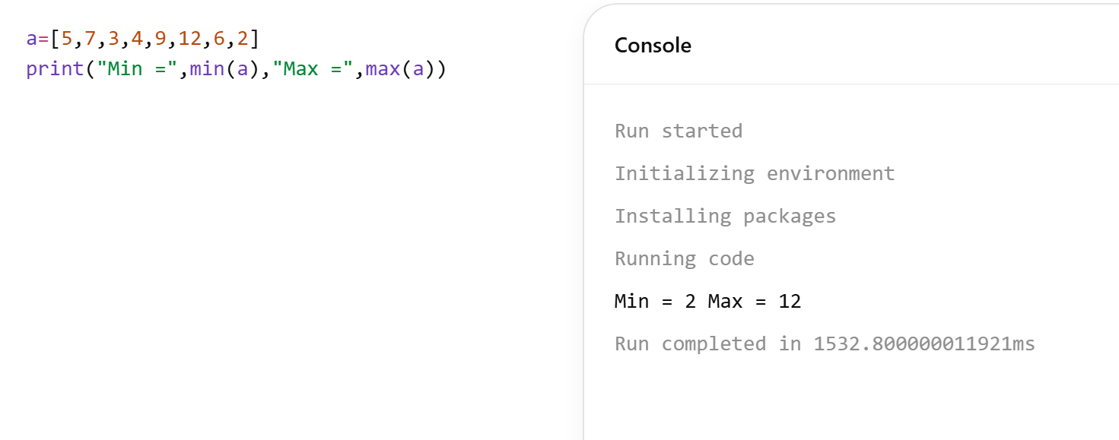

2. Min & Max (Sorted Array)
Aim:
To find minimum and maximum in a sorted array.
Algorithm:
- Take the sorted array as input.
- First element is minimum.
- Last element is maximum.
- No need to traverse.
- Print values.
Output:
Min = 2, Max = 18
Result:
Minimum and maximum values identified correctly.
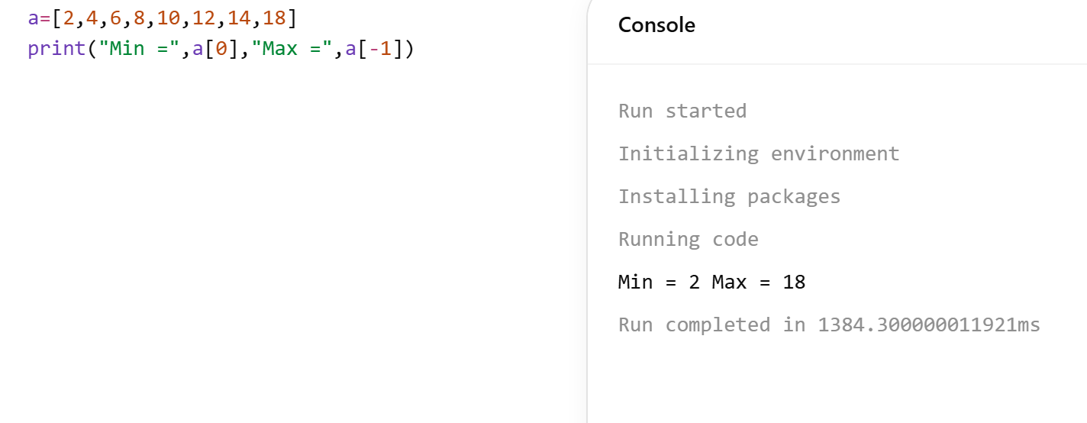

3. Merge Sort
Aim:
To sort an array using Merge Sort.
Algorithm:
- Divide array into two halves.
- Recursively sort both halves.
- Merge sorted halves.
- Compare elements while merging.
- Return sorted array.
Output:
11, 15, 21, 23, 27, 28, 31, 35
Result:
Array is sorted successfully using Merge Sort.
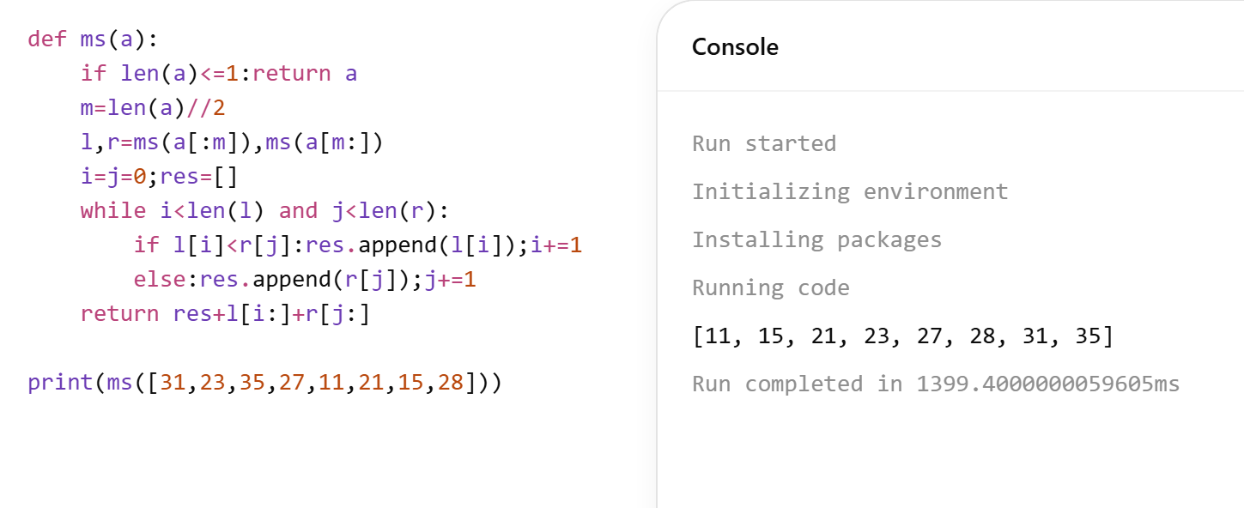

4. Merge Sort with Comparisons
Aim:
To sort array and count comparisons using Merge Sort.
Algorithm:
- Divide array recursively.
- Merge sorted halves.
- Count comparisons during merging.
- Continue until array is sorted.
- Print sorted array and count.
Output:
1, 4, 12, 23, 45, 67, 78, 89
Comparisons = (depends on execution)
Result:
Sorted array and comparison count obtained.

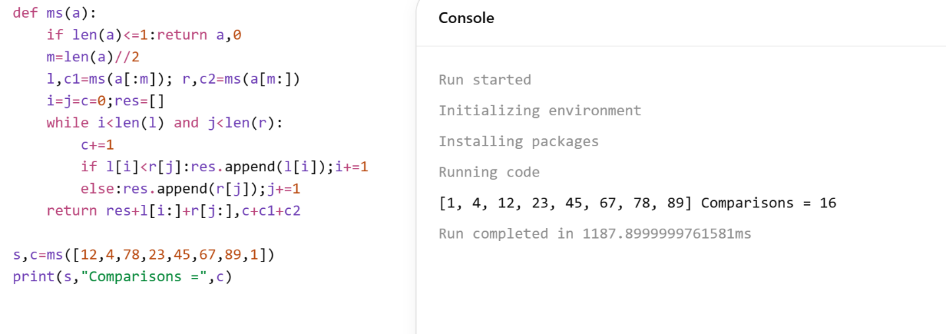

5. Quick Sort (First Pivot)
Aim:
To sort array using Quick Sort with first element as pivot.
Algorithm:
- Select first element as pivot.
- Partition array into two parts.
- Left: elements ≤ pivot.
- Right: elements > pivot.
- Recursively sort both parts.
Output:
3, 5, 6, 8, 9, 10, 12, 15, 16
Result:
Array sorted correctly using Quick Sort.

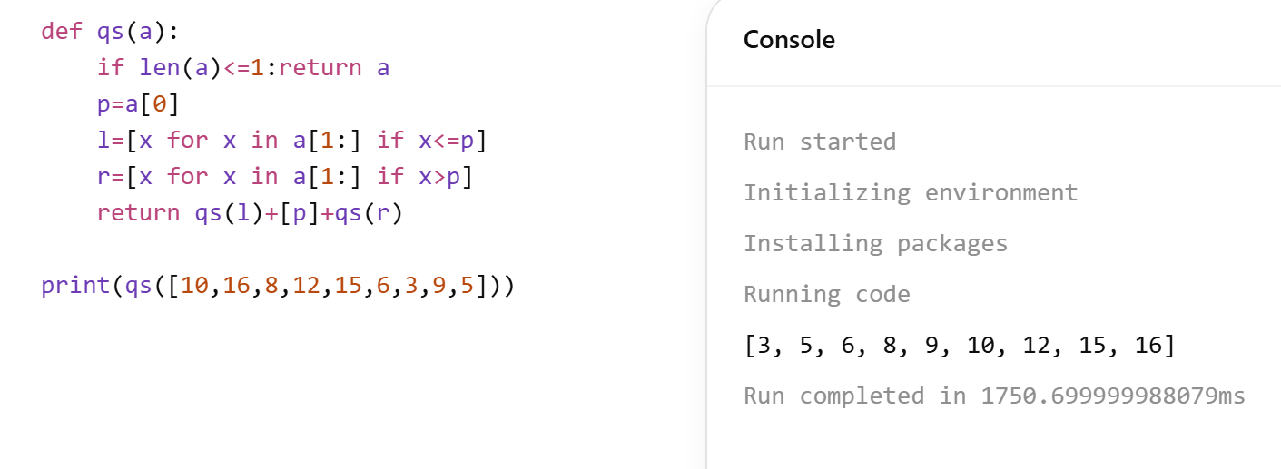

6. Quick Sort (Middle Pivot)
Aim:
To sort array using Quick Sort with middle pivot.
Algorithm:
- Select middle element as pivot.
- Divide into less, equal, greater.
- Recursively sort subarrays.
- Combine results.
- Print sorted array.
Output:
19, 22, 31, 35, 46, 58, 72, 91
Result:
Array sorted successfully.

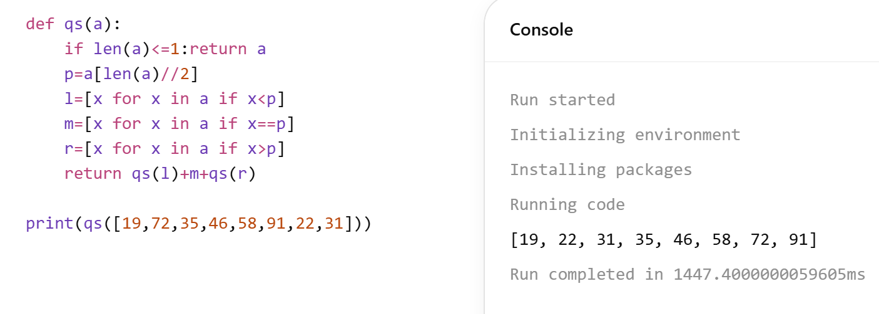

7. Binary Search with Count
Aim:
To find position of element using Binary Search and count comparisons.
Algorithm:
- Initialize low and high.
- Find middle index.
- Compare with key.
- Update search range.
- Repeat until found.
Output:
Position = 4, Comparisons = (count)
Result:
Element found with correct index and comparisons.

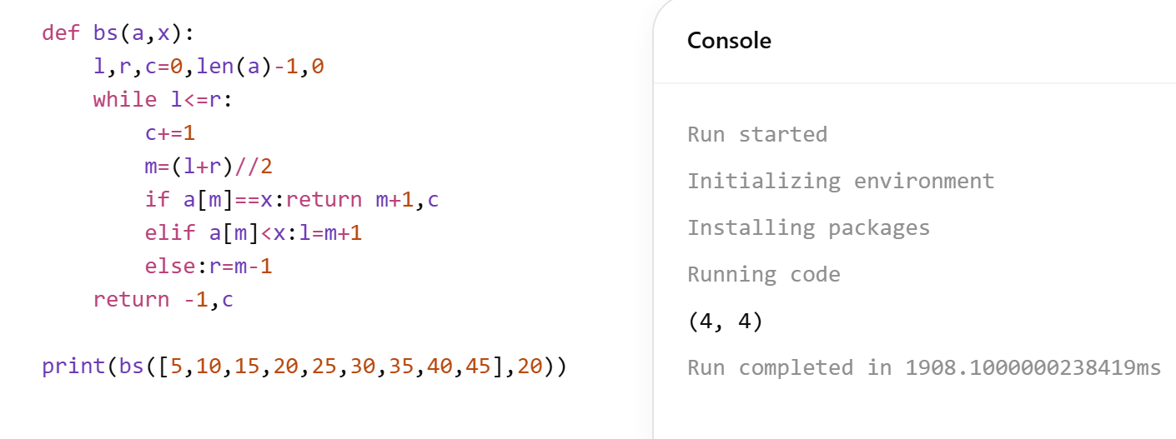

8. Binary Search Steps
Aim:
To trace steps of Binary Search.
Algorithm:
- Initialize low and high.
- Find mid element.
- Compare with key.
- Narrow search range.
- Repeat until found.
Output:
Position = 6
Result:
Element found using Binary Search steps.

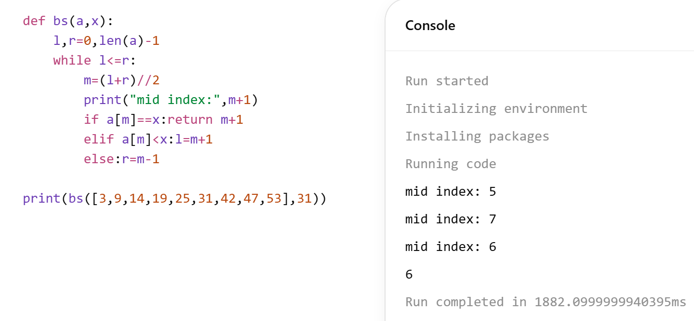

9. K Closest Points
Aim:
To find k closest points to origin.
Algorithm:
- Calculate distance of each point.
- Use sorting or heap.
- Select k smallest distances.
- Store corresponding points.
- Print result.
Output:
[[-2, 2], [0, 1]]
Result:
Closest points are identified correctly.

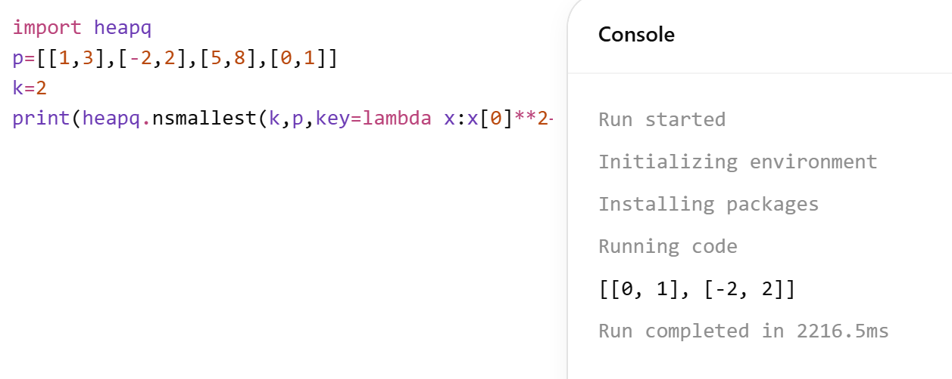

10. 4 Sum Count
Aim:
To count tuples where sum equals zero.
Algorithm:
- Store sums of A and B in hashmap.
- Traverse C and D.
- Find complementary sums.
- Add matching counts.
- Print result.
Output:
2
Result:
Number of valid tuples computed correctly.

